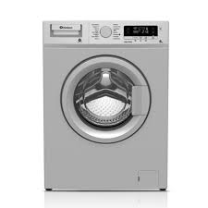

DWD-85400S

* 8.5 KG Capacity
* Less Noise
* 9 Washing Programs
* Tumble Dryer Option
* **Rs.120,000**